I loaded the screenshot into ImageJ, made a vertical line through the colours and extracted the red, green and blue values along the line as three csv files.

# Working with a look-up table derived from RGB pixels

# In Data we have 3 csv files with pixel number and values for R, G, or B

rVal <- read.csv(file = "Data/RValues.csv", header = T)

gVal <- read.csv(file = "Data/GValues.csv", header = T)

bVal <- read.csv(file = "Data/BValues.csv", header = T)

df <- merge(rVal, gVal, by = "X")

df <- merge(df, bVal, by = "X")

names(df) <- c("X","R","G","B")

df$hex <- rgb(df$R, df$G, df$B, maxColorValue=255)

hexVal <- unique(df$hex)

At this point we have the hex values for the coloured bars. Let’s use these colours in a simple barplot.

# use the color palette

barplot(1:16, col = hexVal)

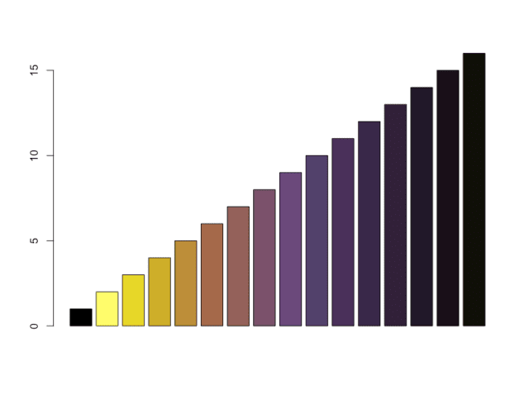

The first colour is black, which is out of sequence, so let’s get rid of it and reverse the order of the colours while we are at it. We can now use the discrete palette or an interpolated palette in an image plot (here using *volcano* as an example).

# delete the first value and reverse

yoshi <- rev(hexVal[2:16])

# use the discrete palette

image(volcano, col = yoshi)

# use an interpolated palette

filled.contour(volcano, color.palette = colorRampPalette(yoshi))

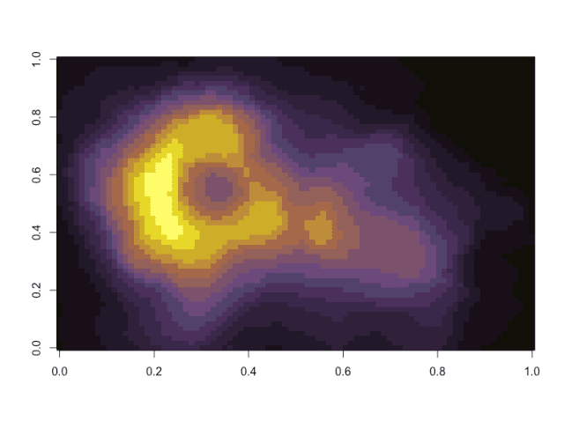

* discrete

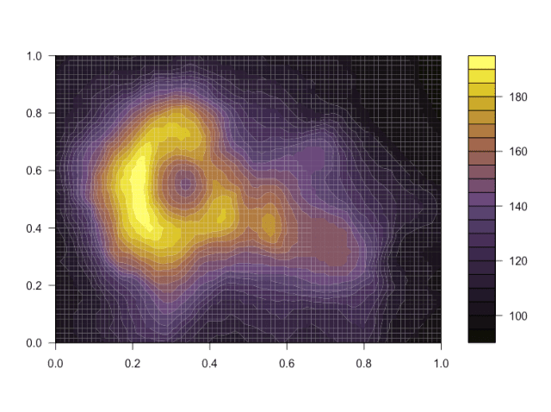

* interpolated

So there you have it, a palette for data visualization in R based on the final level of Yoshi’s Island.

**Back to ImageJ**

It would be great to use this palette as a look-up table back in ImageJ. So, can we export a *.lut file from R for use in ImageJ?

# make a look-up table for use in ImageJ

rgb.palette <- colorRampPalette(yoshi,space = "rgb")

hexpal <- rgb.palette(256)

rgbpal <- t(col2rgb(hexpal))

yoshiLUT <- data.frame(cbind(0:255,rgbpal))

names(yoshiLUT) <- c("Index","Red","Green","Blue")

write.table(yoshiLUT, file = "Output/Data/yoshiLUT.lut", sep = "\t", row.names = F)

The resulting file, yoshiLUT.lut could be loaded into ImageJ and applied to the Rat_Hippocampal_Neuron example image.

Rat_Hippocampal_Neuron (red channel, left) yoshiLUT version (right)

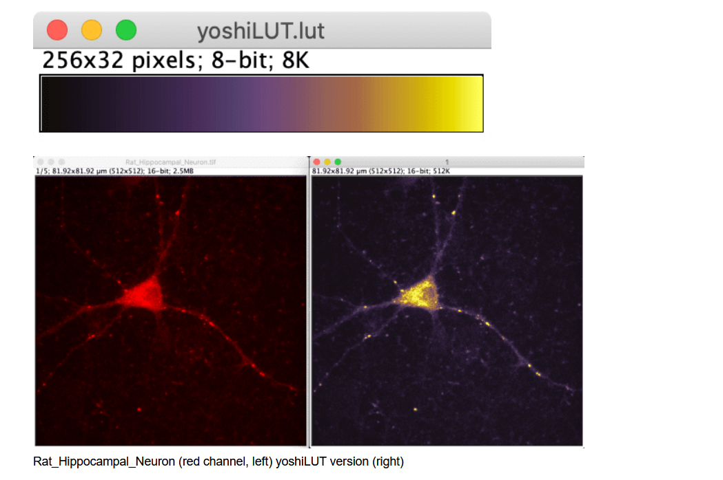

**Conclusion**

Making and using a color table from any starting image is possible, with a bit of data wrangling. Any suggestions for improvement to the code are welcome.